THE CORPORATION OF THE CITY OF ENDERBY

BYLAW NO. 1646

A BYLAW TO IMPOSE DEVELOPMENT COST CHARGES

WHEREAS the Local Government Act provides that Council may, by Bylaw, impose development cost charges on every person who obtains approval of a Subdivision or a Building Permit authorizing the construction, alteration or extension of a building or structure for the purpose of providing funds to assist the local government to pay the capital costs of providing, constructing, altering or expanding sewage, water, drainage and highway facilities, other than off-street parking facilities, directly or indirectly, the development for which the charge is being imposed;

AND WHEREAS Council has taken into consideration the provisions of Section 564(4) of the Local Government Act;

AND WHEREAS the charges imposed by this Bylaw are related to capital costs attributable to projects included in the Official Community Plan and Financial Plan of the City of Enderby;

NOW THEREFORE, the Council of the City of Enderby enacts in open meeting as follows:

- CITATION
  - This Bylaw may be cited as “City of Enderby Development Cost Charges Bylaw No. 1646, 2018”.
- DEFINITIONS
  - In this Bylaw,
“Building Permit” means a permit issued by the City that authorizes the construction, alteration or extension of a building or structure;
“City” means the City of Enderby;
“Council” means the duly elected Council of the City;
“Dwelling Unit” has the same meaning as defined in the Zoning Bylaw, and expressly includes single-family and two-family dwellings, mobile homes, row housing, and multiple family dwellings, but excludes Attached Secondary Suites and Detached Secondary Suites;
“Eligible Development” has the same meaning as defined in section 563(1) of the Local Government Act;
“Subdivision” means a subdivision of land into two or more parcels under the Land Title Act or the Strata Property Act;
“Zoning Bylaw” means City of Enderby Zoning Bylaw No. 1550, 2014.
- DEVELOPMENT COST CHARGES
  - Every person who obtains:

    - approval of a Subdivision; or

    - a Building Permit authorizing the construction, alteration or extension of a building or structure;

shall pay to the City the applicable development cost charges as set out in Schedule “A” and in accordance with the areas specified in Schedules “B” and “C”.

  - Development cost charges shall be collected as follows:

    - Upon approval of a Subdivision of land within zones where a maximum of one dwelling unit per parcel is permitted, at the time of approval of the Subdivision;

    - Upon approval of a Subdivision of land within zones where a maximum of two dwelling units per parcel is permitted, at the time of approval of the Subdivision; and

    - Upon issuance of a Building Permit authorizing the construction, alteration, or extension of a building or structure where development occurs within zones permitting mixed use or more than two dwelling units per parcel.

  - A development cost charge is payable where a Building Permit authorizes the construction, alteration or extension of a building that will, after the construction, alteration or extension, contain fewer than 4 self-contained Dwelling Units and be put to no other use other than the residential use in those Dwelling Units.
  - Every person who obtains a Building Permit shall have paid to the City, at the time of issuing the Building Permit, the applicable development cost charges set out in Schedule “A”, except to the extent that development cost charges were paid in relation to the Subdivision of the parcel in respect of which the Building Permit was issued.

  - The charges specified in Schedule “A” shall be based on the proposed use of the building indicated in the Building Permit application. Where there is more than one such use, each use is subject to the applicable charge specified in Schedule “A”, which shall be calculated separately and then added together for the total development cost charges attributable to the development.
- INSTALMENTS AND REFUNDS
  - A developer liable to pay a development cost charge may elect to pay it by instalments in accordance with the Development Cost Charge (Instalments) Regulation, B.C. Reg. 166/84.

  - All development cost charges imposed may be paid by instalments.
- EXEMPTIONS
  - Development cost charges are not payable in accordance section 561 of the Local Government Act.
- WAIVERS AND REDUCTIONS
  - Council may, by bylaw, waive or reduce a development cost charge payable for Eligible Development.
- DEDUCTIONS
  - Development cost charges must be deducted in accordance with Section 565 of the Local Government Act.

  - Development cost charges imposed pursuant to this Bylaw on residential developments shall be credited one (1) Dwelling Unit for each fully serviced Dwelling Unit that existed prior to the issuance of the Building Permit.
- CREDITS AND REBATES
  - Should a developer wish, with the approval of the City, to proceed with an out-of-sequence development, the costs of the respective works and services provided by the developer shall receive a credit which will be deducted from the applicable development cost charge payable.

  - Should a developer wish, with the approval of the City, to proceed with a development before trunk services fronting the property are installed in the area, a developer may construct the required works to a trunk standard in exchange for a rebate of the incremental portion of costs beyond the local service requirement.

  - Credits and rebates are only applicable to new infrastructure which is included in this Bylaw as an eligible project.

  - No credit or rebate shall exceed the value of the particular development cost charge payable against which it is deducted.
- SEVERABILITY
  - Any section, sub-section, sentence, clause or phrase of this Bylaw that is for any reason held to be invalid by the decision of any Court of competent jurisdiction may be severed from this Bylaw without affecting the validity of the remaining portions of this Bylaw.
- REPEAL OF PREVIOUS BYLAWS AND IN-STREAM PROTECTION
  - City of Enderby Development Cost Charge Bylaw No. 1112, 1994 is repealed in its entirety except as it applies to in-stream applications pursuant to sections 511 and 568 of the Local Government Act, unless the applicant agrees in writing that this Bylaw should have effect.
- EFFECTIVE DATE
  - In all cases except those granted in-stream protection in accordance with Section 8(a) of this Bylaw, this Bylaw shall be effective upon the date of its adoption.

READ a FIRST time this __ day of ____________, 2018.
READ a SECOND time this __ day of ____________, 2018.
READ a THIRD time this __ day of ____________, 2018.

APPROVED pursuant to section 560(1) of the Local Government Act this __ day of ____________, 2018.

____________________________
Inspector of Municipalities

ADOPTED this __ day of ____________, 2018.

____________________________ _______________________________
MAYOR CHIEF ADMINISTRATIVE OFFICER

Schedule “A” - Development Cost Charge Rates

Sanitary Sewer
Area (as shown on Schedule "B") | Development Cost Charge Per Dwelling Unit
Downtown Area | $1,930.50
Knoll Area (A, B, C and D) | $2,247.30
Knoll/Western Uplands Area (E and F) | $1,930.50
Western Uplands Area (G) | $2,871.00

Storm Sewer
Area (as shown on Schedule "B") | Development Cost Charge Dwelling Unit
Knoll Area | $960.00
Western Uplands Area | $510.00

Roads
Area (as shown on Schedule "B") | Development Cost Charge Per Dwelling Unit
Knoll Area | $2,480.00
Western Uplands Area | $2,420.00

Water
Area (as shown on Schedule "C") | Development Cost Charge Per Dwelling Unit
Pressure Zone #1 | $1,805.00
Pressure Zone #2 | $1,740.00

Schedules “B” and “C” - Development Cost Charge Rates

Development Cost Charges Map Schedule “B”, certified true on February 13, 2018 by the Corporate Officer for the City of Enderby, is hereby included by reference.
Development Cost Charges Map “C”, certified true on February 13, 2018 by the Corporate Officer for the City of Enderby, is hereby included by reference.
The reproductions attached to this bylaw have been reduced in size and are for reference only. Where a discrepancy may exist due to the reproduction, the original certified true copies prevail.
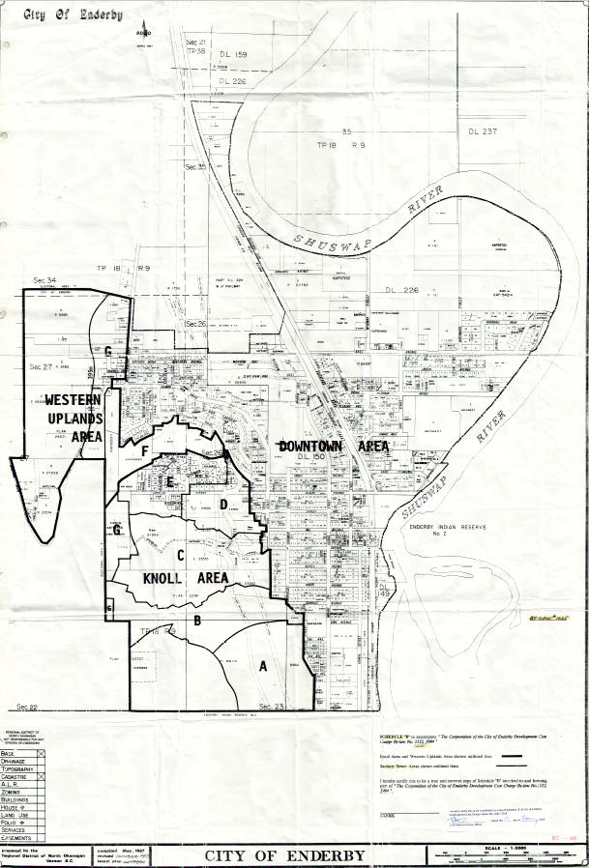
Schedule “B” (reproduction)
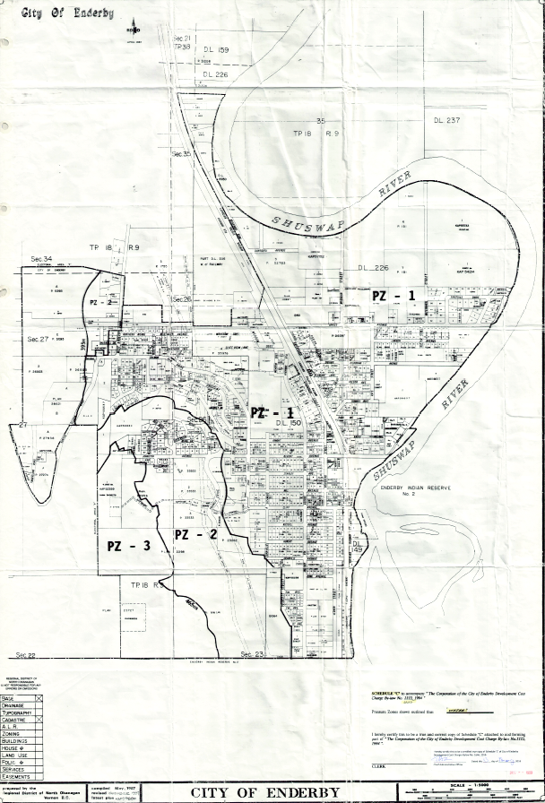
Schedule “C” (reproduction)

